|  |  |  |  |  |  |  |  |
| --- | --- | --- | --- | --- | --- | --- | --- |
| **Monica Mæland,**  Minister of Trade and Industry, Norway | | |  | | | | |
| Nærings- og fiskeridepartementet  Postboks 8090 Dep.  0032 OSLO  **Þorgerður Katrín Gunnarsdóttir,**  Minister of Fisheries and Agriculture, Iceland  **Regierungsrätin Dominique Gantenbein,**  Minister of Home Affairs, Education and Environmental, Liechtenstein  **Bundesrat Johann Schneider-Ammann,**  Minister of Economy and Agriculture, Switzerland | | | | |  | |
|  | |
| Contact person | Our date | | Our reference |  | | | |
| Hildegunn Gjengedal | 23.06.2017 | | 13/00822-27 | | | | |
| +47 90 51 83 79 | Your date | | Your reference |  | | | |
|  |  | |  | | | | |
| EFTA-Mercosur negotiations – the EFTA farmers` views | | | | | |

The EFTA countries newly started the negotiations on a free trade agreement with Mercosur (Brazil, Argentina, Paraguay and Uruguay). We, the undersigning representatives of farmers in the EFTA-countries, would like to present our concerns about these negotiations.

The Mercosur countries are among the largest exporters of agricultural products in the world. Brazil is for instance the world`s biggest exporter of beef and poultry, and number four in pig meat (2015). Also in arable crops the Mercosur countries are large producers and exporters. For instance, together with the US, Argentina and Brazil produce more than 80% of the world`s soya. Brazil and the US have 83% of the world`s soya export markets. Both Argentina and Brazil are among the world`s four biggest exporters of maize. Argentina is the world`s fourth biggest exporter of cereals.

Agriculture in the EFTA countries, Iceland, Liechtenstein, Switzerland and Norway is characterized by small scale family farming, with an average of about 20 hectares and 25 cows in Switzerland, 36 hectares and 37 cows in Liechtenstein, 45-50 cows in Iceland and 25 hectares and 26 cows in Norway. The costs of production are high, topography demanding and the climate severe in many areas of the EFTA-countries.

Also the societal and legal expectations on the production are high in our countries, while much more freedom is given to producers in the Mercosur countries. This would lead to unfair competition in a liberalized market. All these factors contribute to higher prices in our countries, than in the competing Mercosur countries. Beef prices are for instance three times as high in Norway as in Brazil, pig and poultry prices are about 50% lower in Brazil, compared to Norway or Switzerland. By taking into account all such contextual factors, it would be impossible for our farmers and agricultural industry to compete with much cheaper imports from the Mercosur countries. We also register that even our more price efficient colleagues in the EU fear imports from Mercosur countries.

There is also a considerable difference in the food- veterinary and environmental standards between the EFTA-countries and the Mercosur countries. For instance, hormones, GMOs, or the preventive use of antibiotics are not and cannot be used by our farmers. Many (expensive) technical measures are also implemented to protect water bodies from pollution. These are just a few examples of measures taken by our farmers and industry. We are extremely proud of the higher standards that we know our consumers appreciate, but of course this also adds to the costs of our products, and make us less price competitive than our counterparts in Mercosur countries.

Agriculture is an essential industry in our countries. Besides producing food and fibre, it contributes to jobs in the food industry and the delivery industry, a viable countryside, cultural landscapes and biological diversity, which makes it more attractive for national and international tourists to visit our countries. In Norway agriculture employs around 90 000 persons of a population of 5 million, and gives a value added of about 150 billion Norwegian kroners. In Switzerland agriculture provides a total of 200 000 jobs with a turnover of about 20 billion francs a year, not to forget that in alpine valleys agriculture provides up to 50% of the GDP. In Iceland 1,8% of the working inhabitants are employed in agriculture, and agriculture`s share of GDP is 1,1%. In Liechtenstein agriculture employs around 340 persons (0,8%) of a population of 37 000. Around 100 farmers are producing a raw performance of about 38 mill CHF. The self-sufficiency degree of the EFTA countries is already low, and these negotiations will push our agriculture and industries even harder.

Finally, we fear that higher imports of beef from the Mercosur countries will give a “carbon leakage” effect with a negative impact on the global climate reduction policy, since the emissions from beef production in European countries on average are lower than in the Mercosur countries.

When negotiating, our governments must take into account wider societal values, the political wish of a viable agriculture and countryside, and the longer term perspectives of our countries. A sustainable production based on our respective agricultural models cannot be combined with a race to the bottom on price. Our farmers and farm industries do not accept to be a bargaining chip for other sectors in these negotiations.

We therefore warn the EFTA countries against giving the Mercosur countries better market access into our EFTA-markets on agricultural goods, at the expense of our local agricultural production, and all the additional values this provides to our countries.

Yours sincerely,

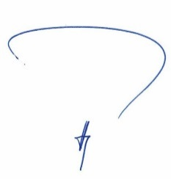

Marcus Vogt, President Farmers` Union Liechtenstein (VBO)

20121129_1

Markus Ritter, President Swiss Farmers` Union (SBV)



Sindri Sigurgeirsson, President Icelandic Farmers` Union

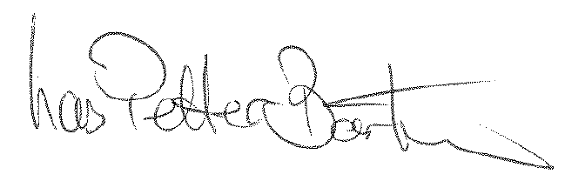

Lars Petter Bartnes, President Norwegian Farmers` Union

|  |  |
| --- | --- |
|  |  |

|  |  |
| --- | --- |
|  |  |